Guide for Adult renewal application (PC7) by mail

Complete your renewal application form online
- The application must be lodged within six months of completion

Print and sign your application form
- Print on plain white A4 paper, using blank ink only. Make sure the top or bottom of the page is not cut off.
- US standard letter paper or US legal paper sizes are also acceptable, but only if they’re scaled properly. Refer to more information on printing your application form
- Sign the form using black pen, within the signature box. Make sure there are no alterations or whiteout on the signature or the date.

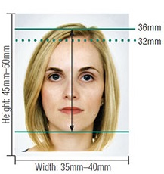
Photos
- Two recent identical colour photos, less than 6 months old with your full name written on the back of one photo. Refer to photo guidelines for more information
- Do NOT attach the photos to the form as this may damage them

Payment
- Please contact the Australian High Commission in Port Vila for payment process
- You can view more information on passport fees https://vanuatu.embassy.gov.au/files/pvla/Fees%20June%202022.pdf

Check your adult renewal checklist
- Before posting your application, review your adult renewal checklist [link to PDF]

Post your application
Australian High Commission
Po Box 111
Port VilaVanuatu

How long will it take?
- Please allow a minimum of eight weeks to receive a new passport once payment has been taken. PLEASE NOTE incomplete applications will cause delays.

